Table of Contents
1 IPA Overview 3
1.1 How IPA works 3
2 Getting started with IPA 5
2.1 Create Workflow in Insight DXP 5
3 Creating and configuring Nodes 7
3.1 Node categories 7
3.2 Creating a solution-based node 8
3.3 Configure nodes for specific tasks 9
3.4 Add actions and fields 9
3.5 Advanced node configuration for platform engineers 10
4 Manage Credentials 11
4.1 Creating credentials 11
4.2 Apply credentials to a workflow 12

IPA Overview
The IPA Framework uses event-driven processing and scales based on workload. It scales to zero when idle and scales up when tasks arrive, supporting different processor types.

How IPA works
IPA uses event-driven scaling and task execution to process workflow tasks efficiently based on incoming messages.
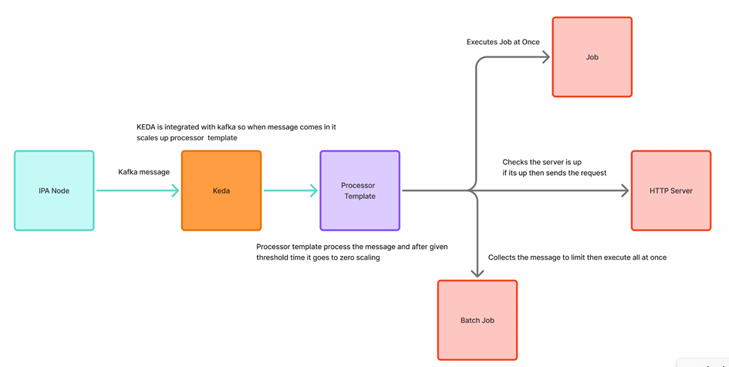
Figure 1: IPA architecture

Event-driven scaling
When an IPA node receives a task, it sends a message to a Kafka topic. The message triggers processing. KEDA (Kubernetes Event-Driven Autoscaling) monitors the Kafka topic and scales the required processor when it detects a new message.
Task execution
The processor uses a processor template to execute the task. Depending on the task type, processing works as follows:
- Job-based: Each message runs as a separate job. The processor runs a configured number of jobs concurrently, while additional jobs wait in a queue until resources are available.
- API-based: The processor starts an API server when required and then executes the request.
- Batch-based: Messages remain in a queue until they reach the configured queue-depth threshold. A Dask processor then processes the queued messages in parallel.

Getting started with IPA
IPA is an Intelligent Processor Framework that executes workflows using various integrations and processors.
Start by creating and naming a new workflow. Workflow changes are not saved automatically, so save your changes manually as you build the workflow.

Create Workflow in Insight DXP
InSight DXP provides centralised access to tools, information, and insights that streamline workflows in the development (dev) environment.
To create the workflow:
- Log in to InSight DXP
  - Open the required development environment from the InSight DXP Environments page.
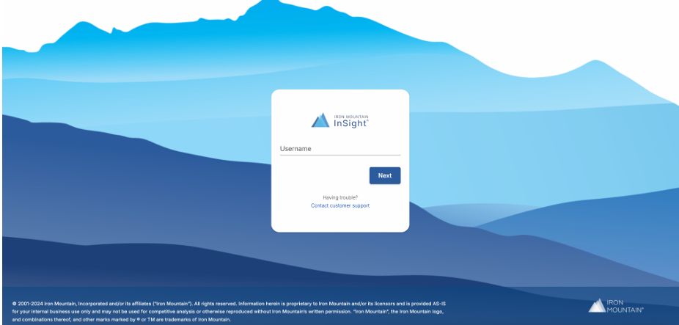
Figure 2: Login screen
  - Enter your Iron Mountain email address in the Username field and select Next.
  - From the Company drop-down list, select World Discovery Demo, and then select Continue.
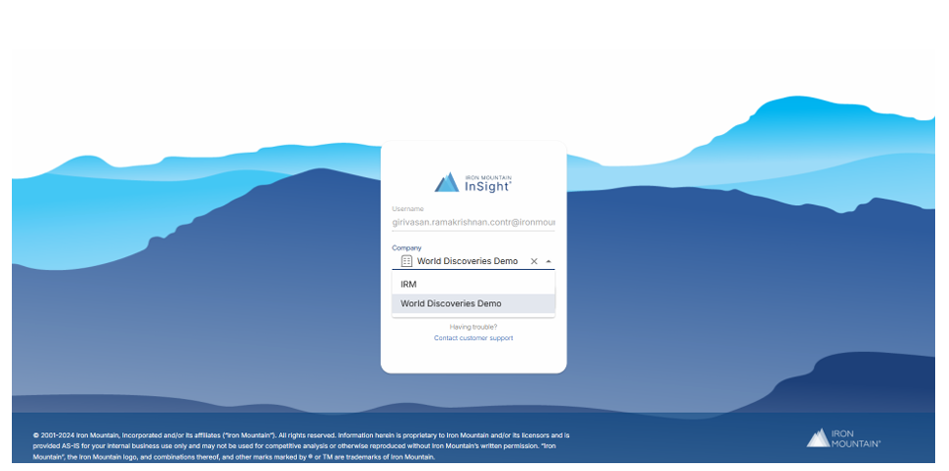
Figure 3: Select from the drop sown list
- Verify the current solution
  - After you log in, the DXP home screen is displayed.
  - Verify the Current Solution displayed in the upper-right corner of the
dashboard.
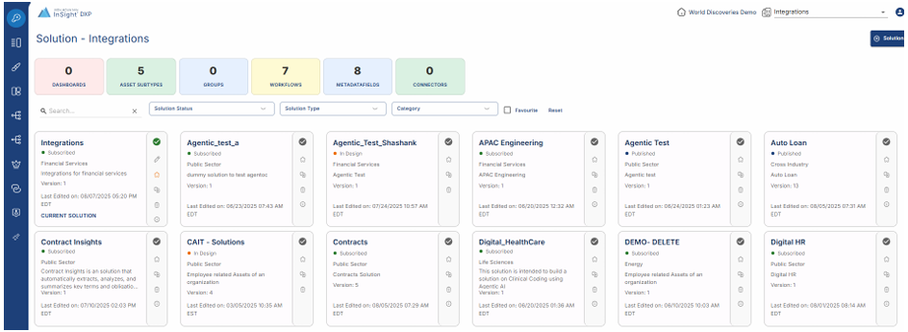
Figure 4: DXP home screen
- Open Workflow Builder
  - Navigate to Workflows V3.
  - Select Workflow Builder.

Creating and configuring Nodes
Nodes are the building blocks of a workflow. Configure each node based on when and how it runs.
Nodes support two trigger types:
- Event-based: Starts the node when a specific event occurs, such as an asset upload, update, deletion, or webhook call.
- Schedule-based: Runs the node at a predefined time or interval, such as hourly or daily.
Note: You can also customise the node name and colour to make the workflow easier to understand.
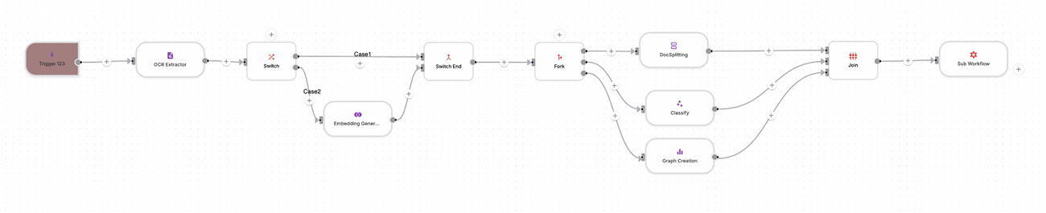
Figure 5: Demo workflow

Node categories
When building a workflow, select a node category based on the task you want to perform:
- Integration: Connects the workflow to external applications, such as SAP or DocuSign.
- Flow: Controls workflow logic, including if-else conditions, exception handling, joins, and sub-workflows.
- AI Agent: Connects the workflow to AI models.
- Content Management: Performs actions on assets or cases.
- Content Enrichment: Performs processing tasks such as Optical Character Recognition (OCR) or embedding.
- Custom Processor: Implements custom logic or executes small code snippets for specialised tasks.
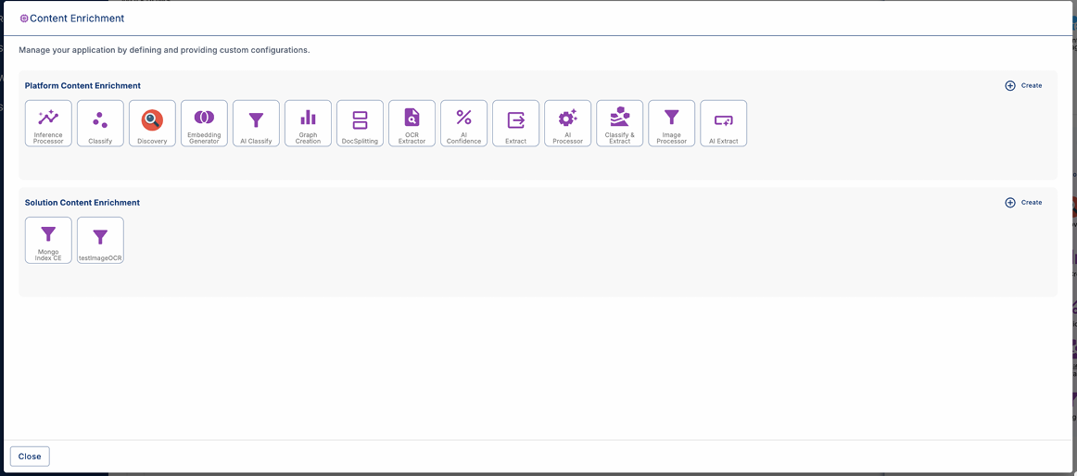
Figure 6: Node categories

Creating a solution-based node
You can create a node in either of the following ways:
- From Settings.
- From a workflow, select Manage under the required node category.
When creating a solution-based node:
- Enter a unique node name.
- Select the appropriate node category.
- Associate the node with the corresponding repository.
- Add or update credentials, if required.
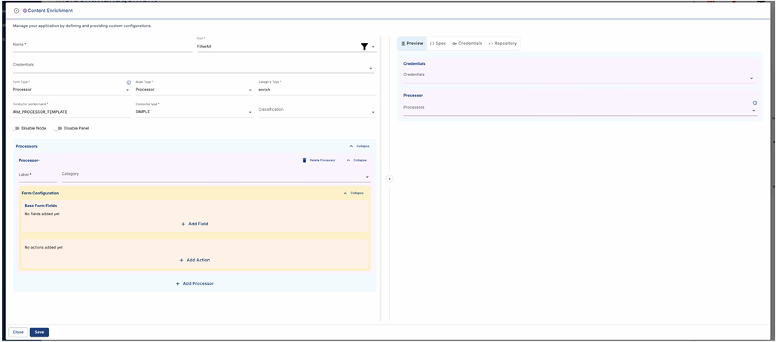
Figure 7: Create node
Note: Ensure the repository matches the node category. For example, use a Content Enrichment repository for Content Enrichment nodes.

Configure nodes for specific tasks
Node configuration depends on the task requirements. For example, when configuring an OCR extractor node:
- Configure the wait timeout: Defines how long the node waits for a response (callback) from the OCR service. If the service does not respond within the configured time, the node fails. Configure the node to continue without waiting when a response is not required.
- Enable parallel processing: Use the Fork feature in a Flow node to run multiple independent tasks in parallel.
- Use a sub-workflow: Add an existing workflow as a sub-workflow when it needs to run as part of the main workflow.
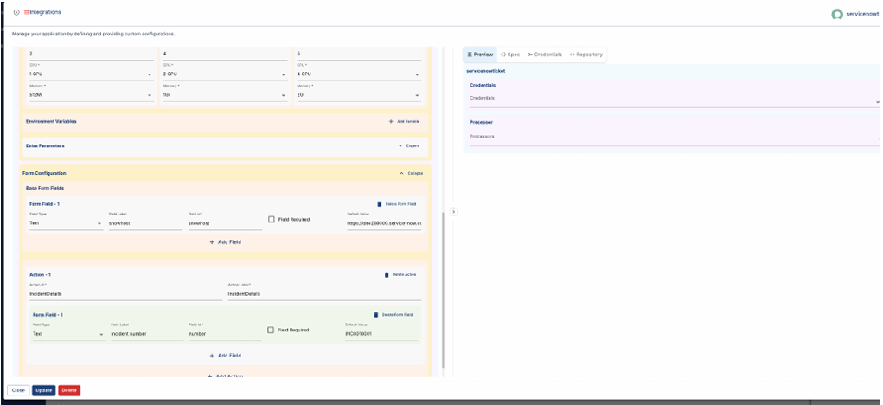
Figure 8: Configure nodes

Add actions and fields
Add configurable fields and actions to a node based on its processing requirements.
- Fields: Configure fields as required or assign default values. The Label is displayed to the user, while the ID identifies the variable used to retrieve the field value.
- Actions: Add actions such as Send Mail or Read Email, with the required fields for each action.
Note: The node's underlying processor image must support the configured actions.

Advanced node configuration for platform engineers
Platform engineers can configure advanced node settings, including:
- Form Type: Defines the right-side configuration panel displayed when a node is selected.
- Node Type: Defines the visual shape of the node in the workflow.
- Category: Defines the node category, such as Content Enrichment or Integration.
- Classification: Defines the classification for Content Enrichment and Content Management nodes.
- Worker Name and Simple Conductor Type: Configure nodes that use a specific architecture.
- Enable/Disable: Controls node availability: Disabling a node prevents users from adding it to a workflow. Disabling its panel allows users to add the node but prevents configuration.

Manage Credentials
Credentials securely store the authentication information that workflows use to access external services. This section explains how to create and use credentials in a workflow.
Types of credentials
IPA supports two types of credentials:
- Solution-level credentials: Available to all users of the solution and used for shared resources, such as database passwords or API tokens.
- User-level credentials: Specific to an individual user account and used for personal authentication, such as a Google login.
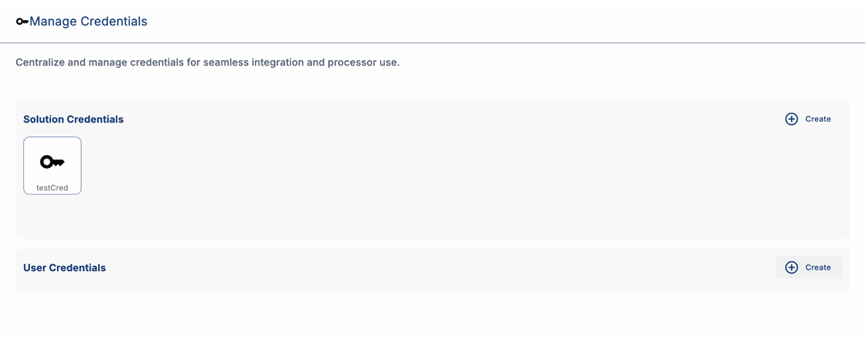
Figure 9: Manage Credentials

Creating credentials
Create a credential based on the external service your workflow connects to.
The supported credential types are:
- API key
- Basic Auth
- OAuth 1
- OAuth 2
- Bearer token
- Google Oauth
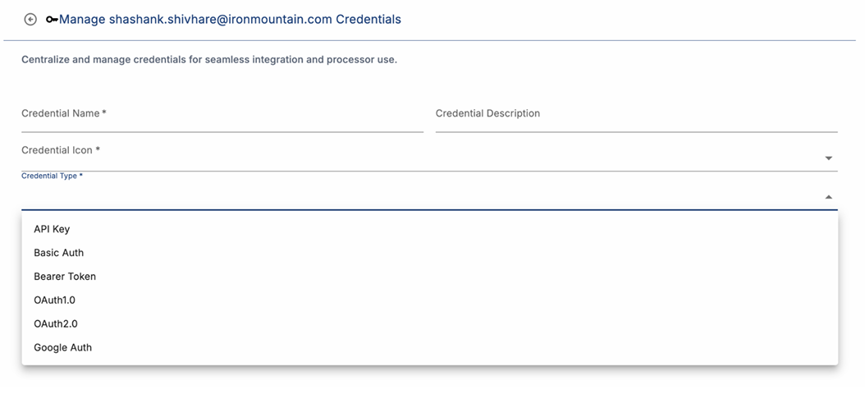
Figure 10: Credential types
When creating a credential, select either solution-level or user-level access.
Note: Solution-level credentials are available to users who have access to the solution. Select the appropriate credential scope based on your access requirements.

Apply credentials to a workflow
After creating a credential, apply it to the workflow node that requires authentication. The credential enables the node to access the required external service or protected resource.
- Open the workflow node that requires authentication.
- Select the required credential from the available credentials.
- Save the node and workflow configuration.
The node uses the selected credential when accessing the configured external service.

Workflow execution
The workflow execution history shows how the workflow runs, what data it processes, and where issues occur. Use the execution details to review and troubleshoot the workflow.

Figure 11: AI Prossessor workflow

Viewing Execution History

